**Bug Report: Google Translate**

**Bug ID: GT-BG-001**

**Bug Title: Incorrect Translation of Special Characters**

**Severity: Medium**

**Priority: Medium**

Description:

When translating text containing special characters, such as punctuation marks or symbols, the translation output does not accurately reflect the input.

Steps to Reproduce:

1. Open the Google Translate webpage using the provided link.
2. In the "From" dropdown, select "English."
3. In the "To" dropdown, select "Sinhala."
4. Enter the text "I'm fine, thank you!" into the text input field.

Actual Result:

The translated text displays as "මම හොඳයි ඔබට ස්තුතියි!" which is correct. However, the punctuation marks are missing in the translation output.

Expected Result:

The translated text should display as "මම හොඳයි, ඔබට ස්තුතියි!" with the punctuation marks included, reflecting the input accurately.

Attachments:

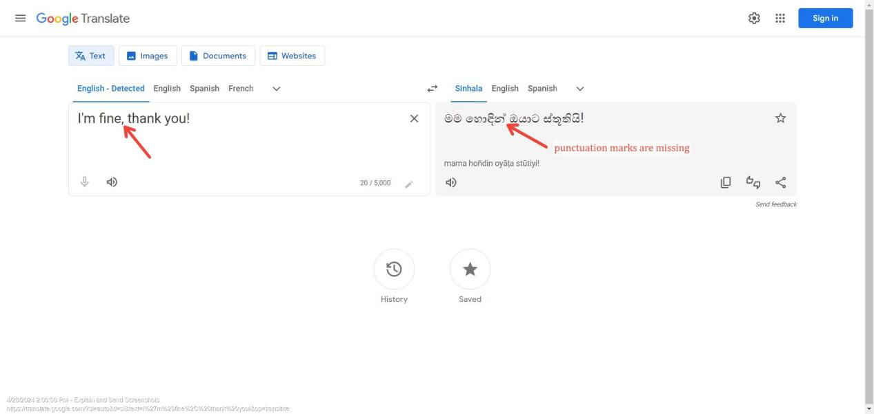

**Bug ID: GT-BG-002**

**Bug Title: Language Detection Failure**

**Severity: High**

**Priority: High**

Description:

The language detection feature of Google Translate fails to detect the correct source language for certain input text.

Steps to Reproduce:

1.Open the Google Translate webpage using the provided link.

2.Enter the text "Bonjour! Comment ça va? How are you?" into the text input field without selecting a source language.

Actual Result:

The detected language is displayed as "Sinhala" instead of "French" and "English."

Expected Result:

The detected languages should include "French" and "English" based on the input text provided.

Attachments:

N/A

**Bug ID: GT-BG-003**

**Bug Title: UI Distortion on Mobile Devices**

**Severity: Low**

**Priority: Medium**

Description:

The user interface elements of Google Translate appear distorted or misaligned on certain mobile devices.

Steps to Reproduce:

1.Open the Google Translate webpage using the provided link on a mobile device with a small screen size.

2.Observe the alignment and layout of UI elements, including text input field, dropdown menus, and translate button.

Actual Result:

Some UI elements appear misaligned, and the text input field may overlap with other elements, affecting usability.

Expected Result:

The UI elements should adjust dynamically to different screen sizes and resolutions, maintaining proper alignment and readability.

Attachments:

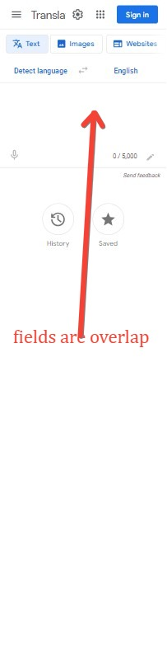

Assigned To: Development Team

Reported By: Vikum

Reported On: 29/04/2024

Status: Open

Resolution: Pending

Target Fix Date: xx/xx/xxxx